TEST PLAN
Migration of the System

Table of Contents

Introduction 3
1.1 Objectives 3
1.2 Team Members 3
2 Scope 3
3 Assumptions / Risks 4
3.1 Assumptions 4
3.2 Risks 4
4 Test Approach 4
4.1 Test Automation 4
5 Test Environment 5
6 Milestones / Deliverables 5
6.1 Test Schedule 5
6.2 Deliverables 5

Introduction
The Test Plan has been created to communicate the test approach to team members. It includes the objectives, scope, schedule, risks and approach. This document will clearly identify what the test deliverables will be and what is deemed in and out of scope.

Objectives
The main goal of this test plan is to validate the new system compatibility with the old system.
This will allow the test team to start transferring tests over to the new system. Must have functionality is considered more important than the delivery date in this project.

Team Members
Resource Name | Role

Scope
The initial phase will include all ‘must have’ requirements. These and any other requirements that get included must all be tested.

Types of Migration

The following are the different types of Migrations that typically happen quite often:
- Application Migration
- Database Migration
- Server Migration
- OS Migration

As the team works with the product they will define the needs for the second phase.
Load testing will not be considered part of this project since the user base is known and not an issue.
Rewriting, moving or porting existing test cases from the existing Word documents is not considered part of this project.

Assumptions / Risks

Assumptions
This section lists assumptions that are made specific to this project.
- Delivery of the product is in format that the test team can check it into CVS.

Risks
The following risks have been identified and the appropriate action identified to mitigate their impact on the project. The impact (or severity) of the risk is based on how the project would be affected if the risk was triggered. The trigger is what milestone or event would cause the risk to become an issue to be dealt with.

# | Risk | Impact | Trigger | Mitigation Plan
1 | Scope Creep – as testers become more familiar with the tool, they will want more functionality | High | Delays in implementation date | Each iteration, functionality will be closely monitored. Priorities will be set and discussed by stakeholders. Since the driver is functionality and not time, it may be necessary to push the date out.
2 | Changes to the functionality may negate the tests already written and we may loose test cases already written | High – to schedule and quality | Loss of all test cases | Export data prior to any upgrade, massage as necessary and re-import after upgrade.
3 | Weekly delivery is not possible because the developer works off site | Medium | Product did not get delivered on schedule
4

Test Approach
The project is using an agile approach, with weekly iterations. At the end of each week the requirements identified for that iteration will be delivered to the team and will be tested.

Exploratory testing will play a large part of the testing as the team has never used this type of tool and will be learning as they go. Tests for planned functionality will be created and added to TCT as we get iterations of the product.
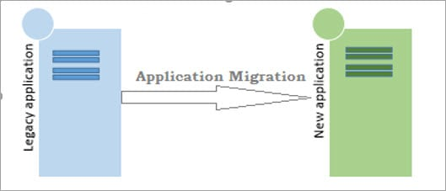

Test Automation
Automated unit tests are part of the development process, but no automated functional tests are planned at this time.

Test Environment
A new server is required for the web server, the application and the database.

Milestones / Deliverables

Test Schedule
The initial test schedule follows……….

Task Name | Start | Finish | Effort | Comments
Test Planning
Review Requirements documents |  |  | 2 d
Create initial test estimates |  |  | 1 d
Staff and train new test resources
First deploy to QA test environment
Functional testing – Iteration 1
Iteration 2 deploy to QA test environment
Functional testing – Iteration 2
System testing
Regression testing
UAT
Resolution of final defects and final build testing
Deploy to Staging environment
Performance testing
Release to Production

Deliverables
Deliverable | For | Date / Milestone
Test Plan | Project Manager; QA Director; Test Team
Traceability Matrix | Project Manager; QA Director
Test Results | Project Manager
Test Status report | QA Manager, QA Director
Metrics | All team members

